**Experiment No: 4a**

To install and configure React and use basic props, components and JSX(This is just a sample program for reference, use different program for your experiment)

App.js

import logo from "./logo.svg";

import "./App.css";

import Header from "./MyComponents/Header";

function App() {

  return (

    <>

      <Header title = 'Welcome' />

    </>

  );

}

export default App;

Header.js

import React from 'react'

import PropTypes from 'prop-types';

export default function Header(props) {

  return (

    <nav class="navbar navbar-expand-lg bg-light">

    <div class="container-fluid">

      <a class="navbar-brand" href="#">{props.title}</a>

      <button class="navbar-toggler" type="button" data-bs-toggle="collapse" data-bs-target="#navbarSupportedContent" aria-controls="navbarSupportedContent" aria-expanded="false" aria-label="Toggle navigation">

        <span class="navbar-toggler-icon"></span>

      </button>

      <div class="collapse navbar-collapse" id="navbarSupportedContent">

        <ul class="navbar-nav me-auto mb-2 mb-lg-0">

          <li class="nav-item">

            <a class="nav-link active" aria-current="page" href="#">Home</a>

          </li>

          <li class="nav-item">

            <a class="nav-link" href="#">About</a>

          </li>

        </ul>

        <form class="d-flex" role="search">

          <input class="form-control me-2" type="search" placeholder="Search" aria-label="Search"/>

          <button class="btn btn-outline-success" type="submit">Search</button>

        </form>

      </div>

    </div>

  </nav>

  )

Header.propTypes = {

title: PropTypes.string.isRequired

};

Header.defaultProps = {

title: 'Default'

};

}

**Experiment No: 4b**

To understand Basic State and Events in React(This is just a sample program for reference, use different program for your experiment)

Using Onclick Mouse Event without using state

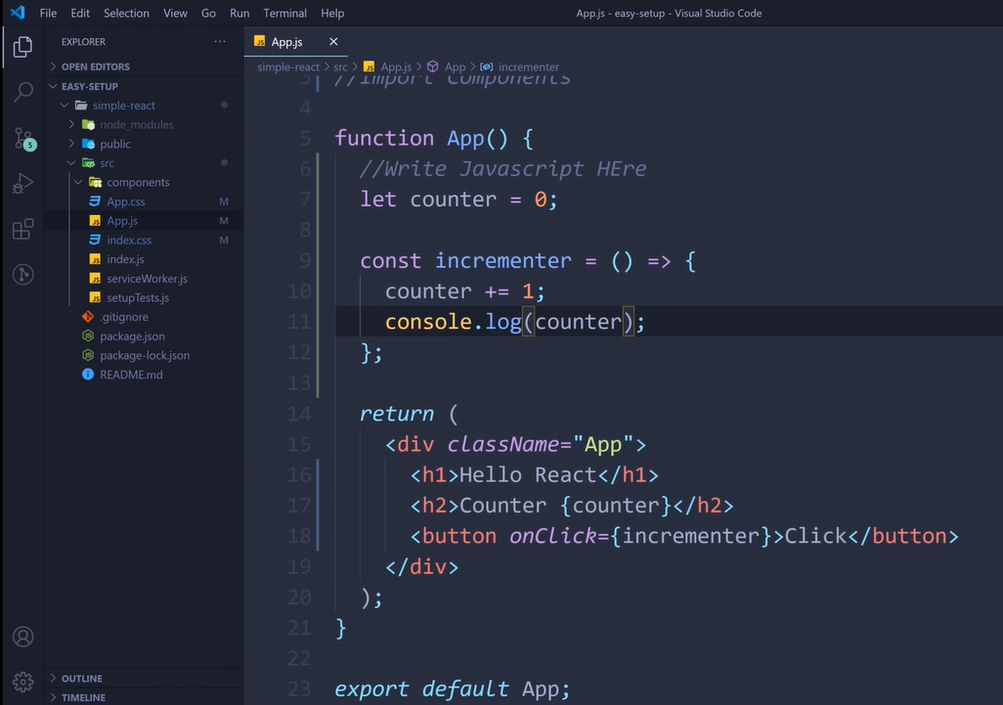

Using Onclick Mouse Event along with state

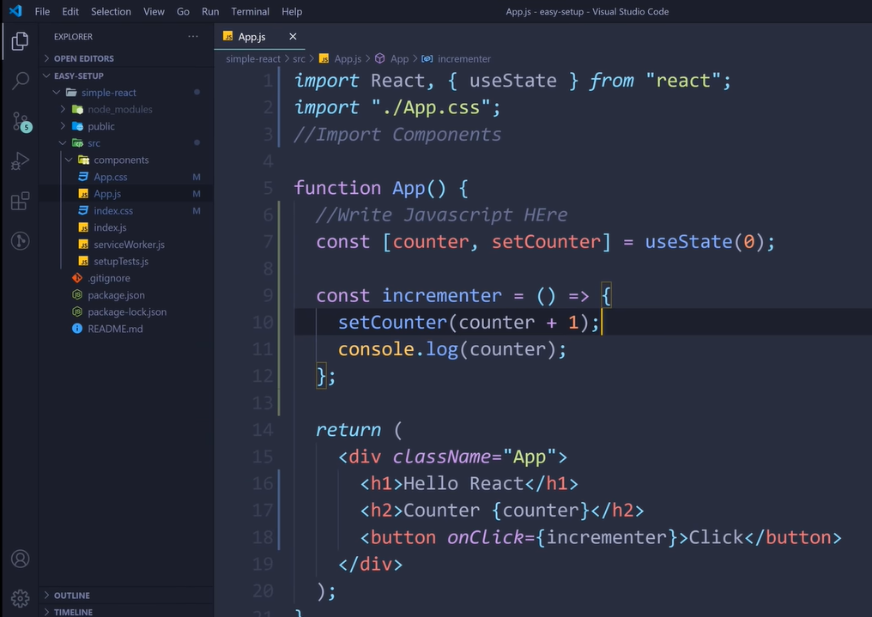

**Experiment No: 4c**

To develop a single page application in react using Router.

Reference code: <https://www.w3schools.com/react/react_router.asp>

**Experiment no: 4d**

To create Controlled and Uncontrolled forms using react js

**Controlled form(import the necessary libraries):**

function ContactForm() {

const [name, setName] = React.useState('');

const [email, setEmail] = React.useState('');

const [message, setMessage] = React.useState('');

function handleSubmit(event) {

event.preventDefault();

console.log('name:', name);

console.log('email:', email);

console.log('message:', message);

}

return (

<form onSubmit={handleSubmit}>

<div>

<label htmlFor="name">Name</label>

<input

id="name"

type="text"

value={name}

onChange={(e) => setName(e.target.value)}

/>

</div>

<div>

<label htmlFor="email">Email</label>

<input

id="email"

type="email"

value={email}

onChange={(e) => setEmail(e.target.value)}

/>

</div>

<div>

<label htmlFor="message">Message</label>

<textarea

id="message"

value={message}

onChange={(e) => setMessage(e.target.value)}

/>

</div>

<button type="submit">Submit</button>

</form>

);

}

**Uncontrolled form(import the necessary libraries):**

function ContactForm() {

const nameRef = React.useRef();

const emailRef = React.useRef();

const messageRef = React.useRef();

function handleSubmit(event) {

event.preventDefault();

console.log('name:', nameRef.current.value);

console.log('email:', emailRef.current.value);

console.log('message:', messageRef.current.value);

}

return (

<form onSubmit={handleSubmit}>

<div>

<label htmlFor="name">Name</label>

<input

id="name"

type="text"

ref={nameRef}

/>

</div>

<div>

<label htmlFor="email">Email</label>

<input

id="email"

type="email"

ref={emailRef}

/>

</div>

<div>

<label htmlFor="message">Message</label>

<textarea

id="message"

ref={messageRef}

/>

</div>

<button type="submit">Submit</button>

</form>

);

}

**Experiment no: 4e**

To create a simple interactive UI using Material UI

(Use as many as components you can from the <https://mui.com/material-ui/react-button/> - this is just a button component. There are many such components available)